Name: Title: Post/Aux. #:

Name: Title: Post/Aux. #:

Address: City: State: AK Zip:



Number of Banquet Tickets: ______x $75 per person

Total Amount: $

Make checks payable to: **VFW Post 9785**. Mail check(s) & Pre-Registration form to:

VFW Post 9785

ATTN: 2024 Department Convention

PO Box 770266,

Eagle River, Alaska 99577

***LODGING OPTIONS***

Camping at Post 9785 – must reserve by calling post at (907) 694-2739. RV Parking available for 16 slots, 6 slots have 110v and 3 slots have 220v power, no water on site. Donations appreciated.

Microtel Hotel in Eagle River (13049 Old Glenn Hwy) – Single Rooms: $99/night, Double Rooms: $115/night, Suites: $125/night. Call (907) 622-6000 to make reservations, ask for the VFW Rate. VFW discount included but they are unwilling to block rooms. First come first serve, so please call soon.

Transportation will be available from hotels to Post 9785 and Lions Park (where Auxiliary meetings and dinners will be held). More to follow on phone number to call closer to convention. Uber and Lyft available from airport to Hotel/VFW.

***MEAL INFORMATION:***

*Cut off for Meal Tickets is 30 April 2024*

Dinner Thursday night at VFW Post 9785, tacos followed by music and dancing.

Dinner Friday night at Lions Park catered buffet style of steak tips and chicken cordon bleu by Sal’s New York Grill and Catering 1800-2000. Cash bar and pull tabs on site hosted by Lions. $10,000 raffle and music following at Post 9785.

Continental Breakfast and Lunch will be available at both Post and Auxiliary meeting sites Friday and Saturday. Cost is included in meal ticket purchase.

Questions? Contact John Raso at (907) 390-7127.

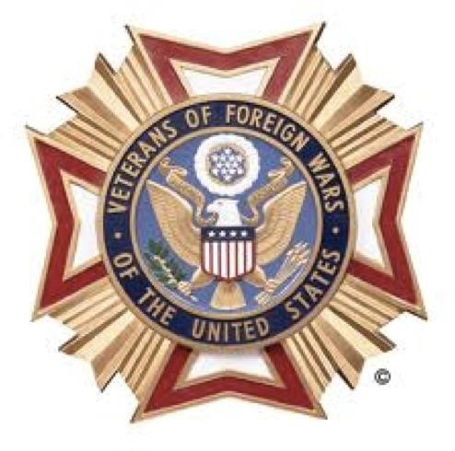*Tentative Schedule of Events*

# **Veterans of Foreign Wars**

**Department of Alaska**

**79th Annual State Convention**

**May 16 – 18, 2024**

**Eagle River, Alaska**

|  |  |
| --- | --- |
| **THURSDAY, MAY 16** |  |
| 3:00 p.m. – 6:00 P.M. | Registration (**Post 9785)** |
| 4:00 p.m. – 5:00 p.m. | Memorial Practice **(Lions Club)** |
| 5:00 p.m. – | No Host Dinner (**Post 9785)** |
| 7:00 p.m. –  **FRIDAY, MAY 17** | Council of Administration (**Post 9785)** |
| 9:00 a.m. | Joint Memorial Service **(Lions Club)** |
| 9:45 a.m. – 12:00 p.m. | Joint Opening **(Lions Club)**  Remarks and Awards **(Lions Club)** |
| 12:00 p.m. – 1:00 p.m. | Lunch **(Lions Club)** |
| 1:00 p.m. – 1:30 p.m. | VFW Business Session **(Post 9785)** |
| 1:30 p.m. – 3:30 p.m. | Officer’s Training **(Post 9785)** |
| 3:30 p.m. – 4:30 p.m. | Committee Meetings **(Post 9785)** |
| 5:00 p.m. – 6:00 p.m. | No Host Cocktails **(Lions Club)** |
| 6:00 p.m. | Distinguished Guest Banquet **(Lions Club)** |
| 8:30 p.m.  **SATURDAY, MAY 18** | $10,000 Raffle Drawing following dinner **(Post 9785)** |
| 9:00 a.m. – 12:00 p.m. | Business Session **(Post 9785)** |
| 12:00 p.m. – 1:00 p.m. | Lunch **(Post 9785)** |
| 1:00 p.m. | Joint Installation of Officers/Close of Convention **(Post 9785)** |
| 3:00 p.m. | Council of Administration **(Post 9785)** |
|  |  |

*Tentative Schedule of Events*

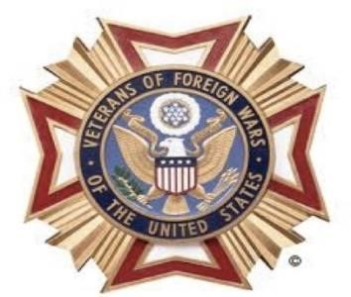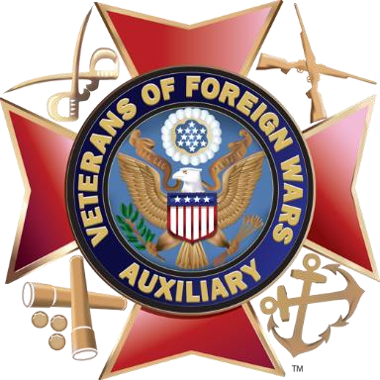

**Auxiliary to the Veterans of Foreign Wars**

**Department of Alaska**

**79th Annual State Convention**

**May 16 - 18, 2024**

**Eagle River, Alaska**

**THURSDAY, MAY 16**

|  |  |
| --- | --- |
| ????? | Officers and Chairmen Meeting / Budget Committee Meeting |
| 3:00 - 6:00 p.m. | Registration – **(VFW Post 9785)** |
| 4:00 - 5:00 p.m. | VFW Memorial Practice(**Lions Club)**  *(Dept. Pres & Chaplain only)* |
| 5:00 p.m. - | No Host Dinner (**Post 9785)** |
| 7:00 p.m. - | Council of Administration (**Post 9785)** |

**FRIDAY, MAY 17 CONVENTION OPENS**

|  |  |
| --- | --- |
| 9:00 a.m. | Joint Memorial Service – **(Lions Club)** |
| 9:45 a.m. – 12:00 p.m. | Joint Opening  Remarks and Awards **(Lions Club)** |
| 12:00 p.m. - 1:00 p.m. | Lunch **(Lions Club)** |
| 1:00 – 2:00 p.m. | Floor Practice |
| 2:00 – 4:30 p.m. | Auxiliary Business Session **(Lions Club)** |
| 5:00 p.m. – 6:00p.m. | No Host Cocktails **(Lions Club)** |
| 6:00 p.m. | Distinguished Guests Banquet **(Lions Club)** |
| 8:30pm | VFW Department $10,000 Raffle Drawing **(Post 9785)** |
| **SATURDAY, MAY 18** | **INSTALLATION OF OFFICERS / CLOSE CONVENTION** |

|  |  |
| --- | --- |
| 7:45 a.m. | Floor Practice **(Lions Club)** |
| 9:30 a.m. – 12:00 p.m. | Business Session / Elections – **(Lions Club)** |
| 12:00 p.m. - 1:00 p.m. | Lunch **(Post 9785)** |
| 1:00 - 2:00 p.m. | Joint Installation of Officers/Close of Convention– **(Lions Club)** |
| 3:00 p.m. | Council of Administration **(Post 9785)** |
|  |  |